USER MANUAL

Pillow Time

CI-103-066-04

June 2019

# GENERAL INFORMATION

## System Overview

PillowTime is an product that allows you to sleep peacefully and wake up without making any noise. It includes an Arduino module that can be embedded in a pillow and a companion app which allows you to set the alarm time and the sleeptracking database.

One simple app can recognize multiple users and different devices, so everyone in the family can enjoy the benefits of revolutionized sleeping.

## Authorized Use Permission

PillowTime website is available to the general public, but you need to buy the module in order to achieve full functionality. The website provides basic information about the functionality of the system.

## Points of Contact

For additional information, please contact Drexel University College of Computing and Informatics.

# WEBSITES FEATURES

## About Page

About page provides a brief introduction to the project as a whole and the website features. By clicking on one of the options in the menu bar, the user can navigate to the described pages.

By clicking on About our system link, you can easily get more information about the hardware components that our system uses.

## About Our System page

About Our System page provides more information about the hardware components of our system.

Clicking on the back link leads you back to our About page.

## Creating a User

In order to create a user, you need to navigate to the Add User page by clicking Add User in the menu. Creating a user allows you to set alarm times and access the sleeptracking database that is related to the user. Anyone using a computer with created users can view all records in the database.

The Add User screen displays as shown below.

Type in the User ID. After filling in the data appropriately as shown below and clicking on the Submit button, a message saying that a user has been created will display on the screen as shown below:

In case you wanted to modify the alarm time associated with a user, you can do so through the Users page. Add User page procedures are only meant to be done once in order to preserve integrity of sleeptracking database and maintain consistent data collection.

## Duplicate user errors

In case a user with a submitted User ID already exists, a message alerting you that you have entered an invalid username will show. A duplicate username will not save to the database and you can enter a new username.

## Displaying a list of users

After creating a user, you can navigate to the Users tab and see all the users created on the computer you are using. The Users page looks like this:

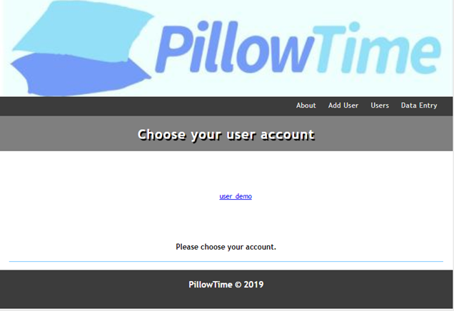

You can see the user we created in the previous steps, and in the event of more users they would show up in the list based on the times they were created. For frequent users this page represents the majority of the systems functionality.

## Modifying the alarm time

Clicking on a username, navigates you page to a page similar to the Add Users page, as shown below:

You can enter a time to set the alarm off, and you can save it in settings by clicking the Submit button. The graph at the bottom of the webpage shows the computed sleep times for that user.

## Manually entering data

In case you missed a night of sleep on your pillow with embedded PillowTime, you can manually enter data by navigating to the Data Entry page. The page allows you to choose a user to append the sleep data to, as well as, input a time when you started sleeping and a time when you woke up. By clicking on the Submit button you submit the data, and our program calculates the time spent sleeping. In order for the program to work, the time needs to follow the format outlined by the placeholder values.

The following picture shows the Data Entry page:

Upon entering times, your Data Entry page should look like this:

After clicking the Submit button, you are navigated back to the Users page and the graph associated with the chosen user will show a point that represents the amount spent sleeping:

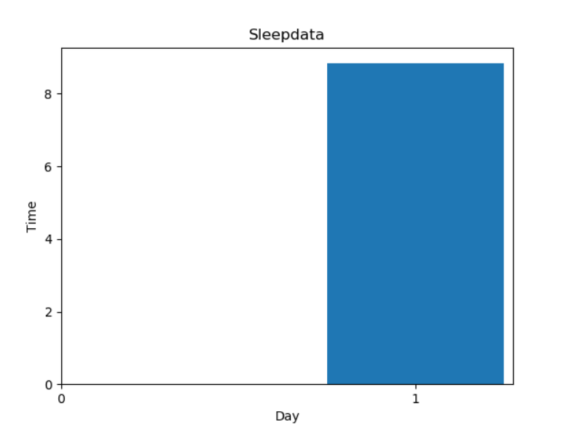

# Connector

## Getting to the Connector

Once you have installed the connector. In order to run it, you need to get the location where you have downloaded/installed it. This can be done through your command prompt. Through the start menu, search command prompt and open.

Through this you will use the “cd” function and then enter the path location of where the connector is located. Below is an example:

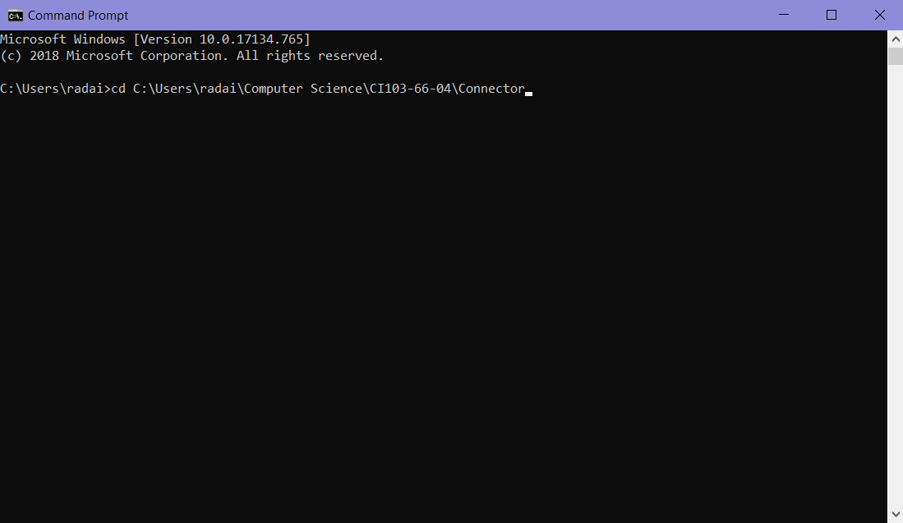

## Running the Connector

Once you have gotten to the file location, next comes running the program. This can also be done through the command prompt, and is shown as follows with the following line:



Once this is entered, the connector will run and begin to initiate the connection between the website and your pillow.

## Inputting Username and Setting Alarm

Once the connector has begun running. It will check to see what port you have connected the pillow alarm clock too. After it has searched and found it, it will prompt you to input your username. This the username that you used on the website. It uses this username to go to your user page on the website and get the alarm time that you have input. It will take the alarm time and set that alarm on the pillow alarm.



## Sleep Tracking Data

Every time that you initiate a connection with the pillow alarm, it will send back the sleep tracking data that it has stored since the last time that you have connected. The connector automatically sends this data back to the webpage and updates your sleep tracking graph for you automatically.